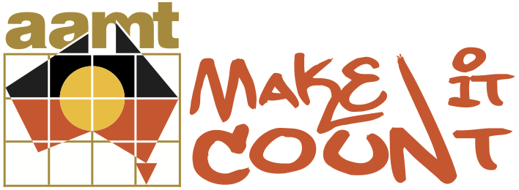

Nerang Cluster 2012 Conference Report

The Project:

An overnight Mathematics conference for Maths teachers from Catholic and State Primary and High Schools.

The Nerang Make It Count cluster has, throughout its involvement in this project, maintained a focus of improving the quality of Mathematics teaching provided to indigenous students in the six schools. In 2012, one way this was addressed was to host a conference for teachers of Mathematics in the Nerang 'Make It Count' cluster. The theme of the conference was Culturally Responsive Mathematics Teaching. The conference was held on the Gold Coast during the Professional Development Days in January.

The Aim:

The aim of the conference was to move all teachers beyond the idea of cultural competency to acceptance of a responsibility to respond to the individual needs of indigenous learners in order to improve Mathematics learning for those students. Teachers at each of the six schools in the cluster had previously been involved in cultural competence training and professional learning in the area of mathematics teaching and learning for indigenous children. Some teachers had also taken on action learning projects where they investigated an aspect of their own teaching of mathematics to indigenous students. This conference was a vehicle for sharing the learning that had been made in each school over the three years of project involvement. It was also seen as an opportunity to ensure all teachers of Mathematics received a consistent message about the importance of quality teaching for indigenous learners of Mathematics.

The Logistics:

The delegates were one hundred and fifty Primary and Secondary teachers of mathematics from six schools from both the Catholic system and State sector. Some delegates had been heavily involved in the Make It Count project for 3 years, others were new to the cluster and had no background in indigenous education. Most had been involved in earlier professional learning sessions around Cultural Competency and effective pedagogy for teaching Mathematics to indigenous students. The conference was held over one evening and the following day. Delegates were accommodated at the Radisson Resort, Palm Meadows, on the Gold Coast.

The structure of the conference was agreed by the Nerang Cluster leadership team, made up of Principals, Assistant Principals or delegate from each of the six schools. The overnight aspect of the conference was included to allow for presentations and activities beyond the single day of professional learning time that schools had available for this curriculum focus. Speakers were selected for their ability to provide quality professional learning for teachers of mathematics from Prep to Year 12. Two keynote addresses were planned: one to focus on effective mathematics pedagogy and the other to explore the needs and characteristics of indigenous learners of mathematics and the responsibility of teachers to meet those needs. A casino night was planned to follow the opening address to engage the teachers in the use of mathematics beyond the traditional classroom. The final session of the conference was an opportunity for each school to share their progress toward the project aim of improving mathematics outcomes for indigenous students.

The Presenters:

Welcome to Country: Uncle Graham Dillon, spokesperson for the Kombumerri people; elder in residence, Griffith University

Opening Address: Mr Ian Mackie, Assistant Director General Indigenous Education and Training Futures, Queensland

Keynote Address and Workshops:
- Dr Peter Grootenboer, Associate Professor, Convener M. Ed Program, Griffith University, Nerang Cluster Critical Friend 'Make It Count'
- Dr Tyson Yunkaporta , Education Consultant

Workshops:
- Dr Annette Duffy, Area Supervisor, Brisbane Catholic Education
- Dr Chris Matthews, Co-ordinator of Indigenous Research Network, Griffith University
- Ms Jo Kimmins, Education Officer, Brisbane Catholic Education
- Ms Caty Morris, AAMT National Manager: Indigenous Projects

The Program:

19 January, 2012

6.30pm Welcome to Country – Uncle Graham Dillon, spokesperson for the Kombumerri people; elder in residence, Griffith University

7pm Buffet Dinner

8pm Opening Address – Mr Ian Mackie, Assistant Director General Indigenous Education and Training Futures, Queensland

8.45pm Casino Hour

9.45pm Evening Close

20 January, 2012

8.30am Keynote Address Dr Tyson Yunkaporta , Education Consultant – ‘Culturally Responsive Pedagogy in Mathematics’

9.30am Workshop Session 1
Dr Tyson Yunkaporta , Education Consultant – ‘Culturally Responsive Pedagogy in Mathematics’
Ms Jo Kimmins, Education Officer, Brisbane Catholic Education – ‘Problem solving with the Australia Mathematics Curriculum’
Dr Chris Matthews, Co-ordinator of Indigenous Research Network, Griffith University – ‘The Culture of Mathematics’
Dr Peter Grootenboer, Associate Professor, Convener M. Ed Program, Griffith University – ‘Building Confidence and Fostering Engagement in Mathematics’
Ms Caty Morris – ‘Numeracies in Indigenous Communities’
Dr Annette Duffy, Area Supervisor, Brisbane Catholic Education – ‘Spirit of the Flame – Indigenous Leadership’

10.45am Workshop Session 2

11.30am Keynote Address: Dr Peter Grootenboer, Associate Professor, Convener M. Ed Program, Griffith University – ‘Building Confidence and Fostering Engagement in Mathematics’

1.15pm Leading from the Middle – Cluster schools presentation (6 Minutes per school)

2pm Conference wrap up and close

The Outcomes:

Participation in the workshops and casino night activities was high. Teacher feedback was that they felt valued as teachers of Mathematics, many never before having participated in a conference of this nature. Surveys were distributed to each school after the event. Teachers were asked to rate their experiences in workshops and Keynote presentations; synthesise what they heard about Mathematics education for indigenous students and identify an area of professional practice they would adapt as a result of any learning made at the conference.

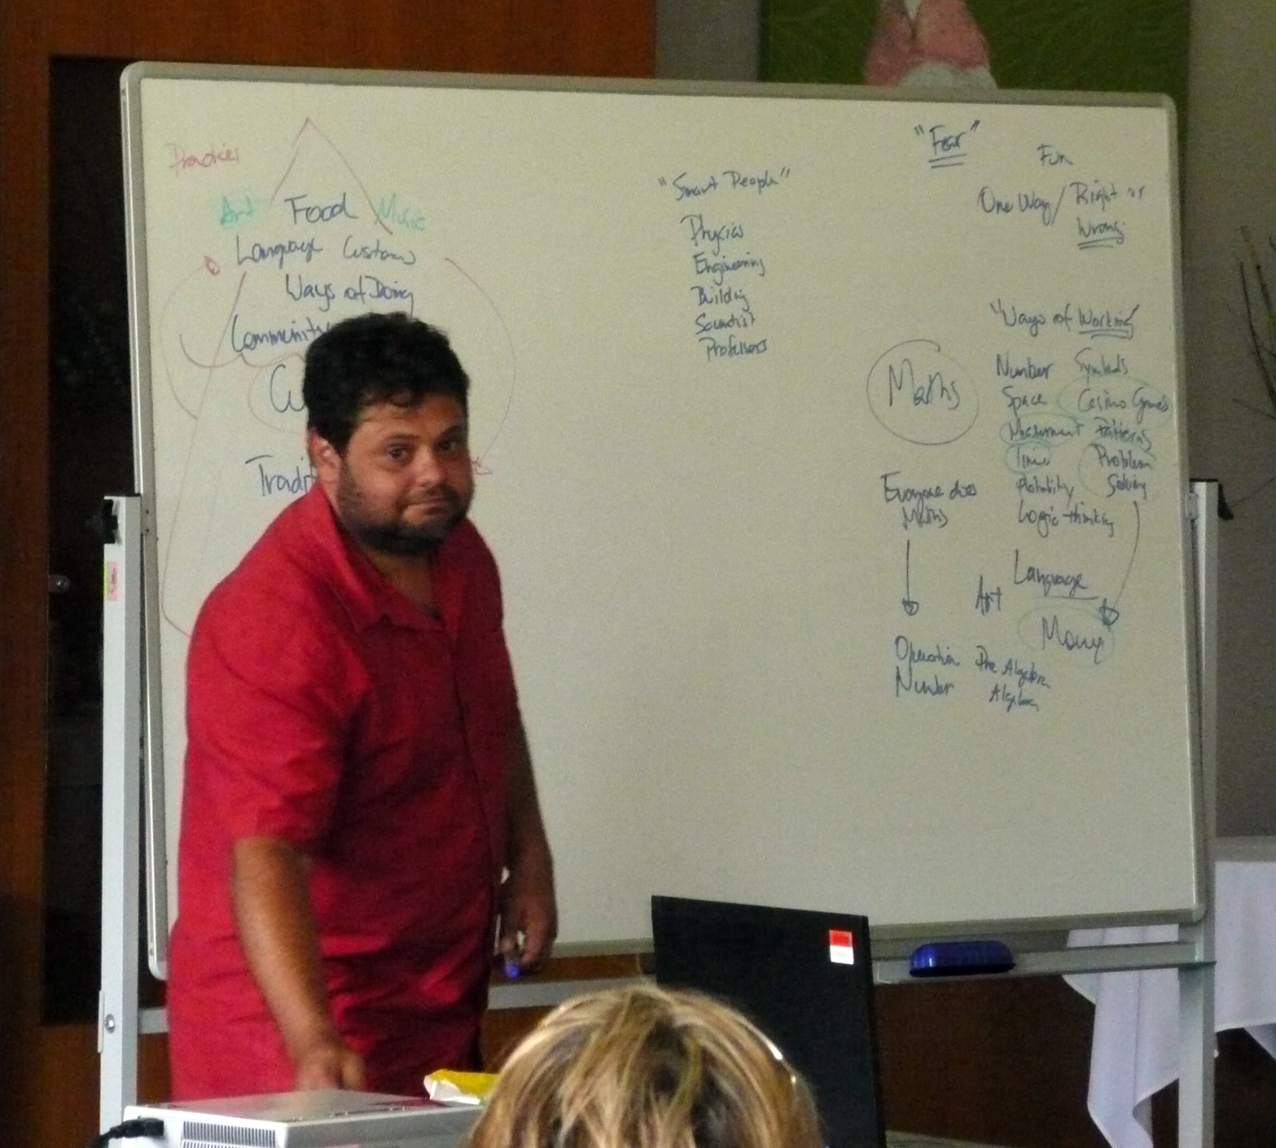

Dr Chris Mathews presenting at the conference.

Although not all surveys were returned, there were trends that could be seen in the responses collected. Overall feedback was positive and teachers were able to articulate their understanding of the importance of culture to effective learning of Mathematics for indigenous children. The content identified as most challenging was the idea of teachers needing to be culturally responsive, rather than merely aware of cultural differences. Teachers identified this as a challenge as they felt they needed more knowledge in this area to be truly effective. Teachers who had been involved in action research throughout the life of the 'Make It Count' project responded most positively to all aspects of the presentations and were most able to identify a new area of interest for professional development in the area of improving mathematics outcomes for indigenous students. Presentations that were rated as most useful were those with an interactive or hands on component where teachers felt they could take ideas back to their classrooms to try out.

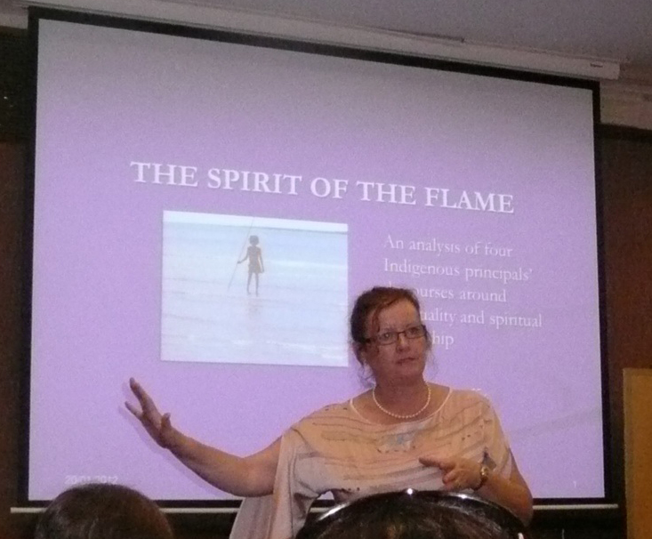
Dr Annette Duffy presenting at the conference.

The Future:

Cross-sectoral conferences of this nature provide many opportunities to share knowledge and understandings, access quality presenters and create partnerships to benefit indigenous students in all schools in a local area. While an overnight conference comes with significant costs, a similar outcome could be achieved and sustained over time by running a one day conference at a low cost venue. The greatest benefits reported were by teachers who felt they had some background in the topics presented. Pre-reading or prior learning for all staff would allow more teachers to access the information presented at a deeper level. Making explicit the links between theoretical and practical sessions would allow more teachers to make connections between the ideas presented and their own teaching.

Karen Petherick
St Brigid’s Primary School
Nerang

